Nutrition Per Serving:
calories protein carbohydrate total fat
Prep time: Total time:
Yield: Serving size:
341
- g
- g
6.4 g
30 minutes
30 minutes
Serves 4
1 Pita

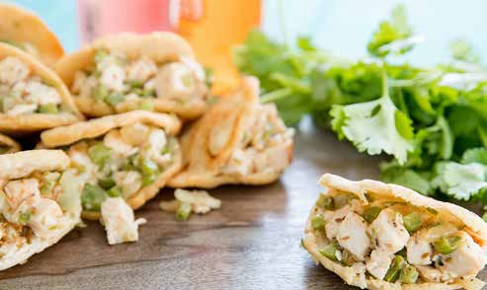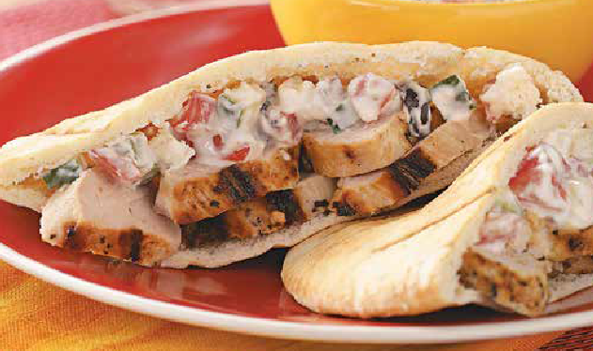TURKEY PITAS WITH TAHINI-YOGURT SAUCE
ground cumin paprika kosher salt
ground turmeric (4-ounce) turkey cutlets
(6-inch) whole-wheat pitas
thinly sliced cucum-
1.5 tablespoons sauce
Ingredients: Cooking spray 1 teaspoon
1 teaspoon 1/4 teaspoon 1/4 teaspoon 4

4

1 cup ber
1 cup

Step 1
Heat a grill pan over medium-high heat. Coat pan with cooking spray. Combine cumin, paprika, salt, and turmeric in a small bowl. Rub spice mixture evenly over turkey. Add turkey to pan; cook 3 minutes on each side or until done. Remove turkey from pan.
thinly sliced red bell pepper
tahini (sesame seed paste)
plain low-fat yogurt
2 tablespoons

Step 2
2 tablespoons
Cut off top third of each pita; reserve for another use. Add pitas to pan; grill 30 seconds on each side or until marked. Cut turkey into slices. Divide turkey, cucumber, and bell pepper evenly among pitas.
freshly ground black
1 tablespoon water 1/2 teaspoon
1 1/2 tablespoons fresh lemon juice

Step 3
pepper
Combine tahini and remaining ingredients in a small bowl, stirring with a whisk. Serve tahini mixture with sandwiches.

Copyright 2018, AIR, Inc. All rights reserved.

